**10.FEATURE SCALING**

**NAME : ENIYA.B.A**

**ROLL NO : 230701085**

**AIM: To do feature scaling in the given dataset.**

import numpy as np

import pandas as pd

df=pd.read_csv('Data.csv')

df.head()

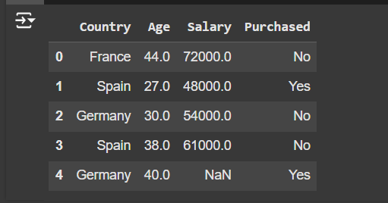

df.Country.fillna(df.Country.mode()[0],inplace=True)

features=df.iloc[:,:-1].values

label=df.iloc[:,-1].values

from sklearn.impute import SimpleImputer

age=SimpleImputer(strategy="mean",missing_values=np.nan)

Salary=SimpleImputer(strategy="mean",missing_values=np.nan)

age.fit(features[:,[1]])

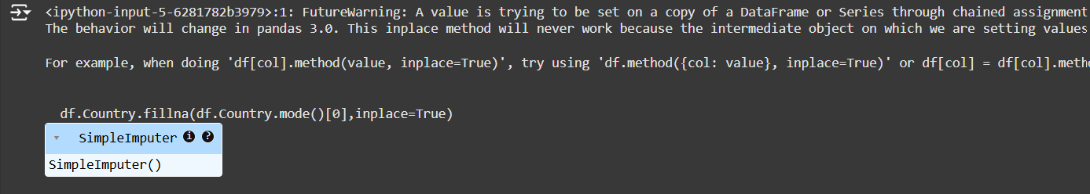

Salary.fit(features[:,[2]])

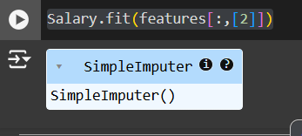

SimpleImputer()

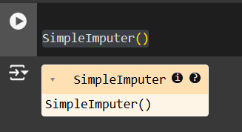

features[:,[1]]=age.transform(features[:,[1]])

features[:,[2]]=Salary.transform(features[:,[2]])

features

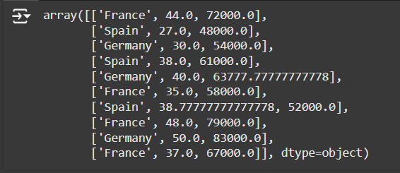

from sklearn.preprocessing import OneHotEncoder

oh = OneHotEncoder(sparse_output=False)

Country=oh.fit_transform(features[:,[0]])

Country

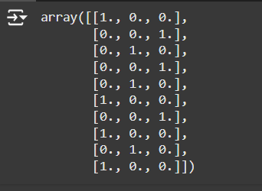

final_set=np.concatenate((Country,features[:,[1,2]]),axis=1)

final_set

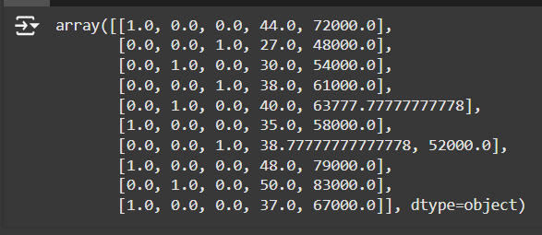

from sklearn.preprocessing import StandardScaler

sc=StandardScaler()

sc.fit(final_set)

feat_standard_scaler=sc.transform(final_set)

feat_standard_scaler

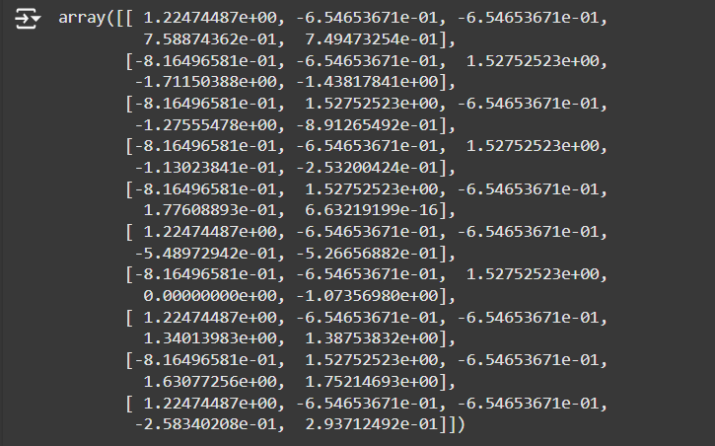

from sklearn.preprocessing import MinMaxScaler

mms=MinMaxScaler(feature_range=(0,1))

mms.fit(final_set)

feat_minmax_scaler=mms.transform(final_set)

feat_minmax_scaler

